# FOCS Homework 10, for Day 11

You may edit your answers into this file, or add a separate file in the same directory.

If you add a separate file, please include the following at the top:

```

Student Name: Frankly Olin [change to your name]

Check one:

[ ] I completed this assignment without assistance or external resources.

[ ] I completed this assignment with assistance from ___

and/or using these external resources: ___

```

## I. Logic

### 1.

The following tables are [truth tables](https://en.wikipedia.org/wiki/Truth_table).

_true_ and _false_ are represented by `T` and `F`. _OR(false, true)_ is commonly written in [infix notation](https://en.wikipedia.org/wiki/Infix_notation): `F OR T`.

The second table shows the value of the function _a OR b_, for all possible values _a_ and _b_. For example, _false OR true_ (the second row) has the value _true_ (the final cell of that row).

_a_ | _b_ | _a_ AND _b_

----|-----|---

F | F | F

F | T | F

T | F | F

T | T | T

_a_ | _b_ | _a_ OR _b_

----|-----|---

F | F | F

F | T | T

T | F | T

T | T | T

_a_ | _b_ | _a_ XOR _b_

----|-----|---

F | F | F

F | T | T

T | F | T

T | T | F

a. Construct the truth table for _a XOR (b XOR a)_.

_a_ | _b_ | _a XOR (b XOR a)_

----|-----|---

F | F | F

F | T | T

T | F | F

T | T | T

b. Which function corresponds to the English word "or", as used in "You will eat your meat OR you can't have any pudding" (where _a_ = "You will eat your meat" and _b_ = "you can't have any pudding").

The function XOR corresponds to the English word "or" in the context.

## II. Questions 2–6 are the same as in-class activities 2-6

### 2.

Consider the following context-free grammar G:

```

E -> E + E | T # <- added "| T"

T -> T x T | (E) | a

```

Convert G to a PDA.

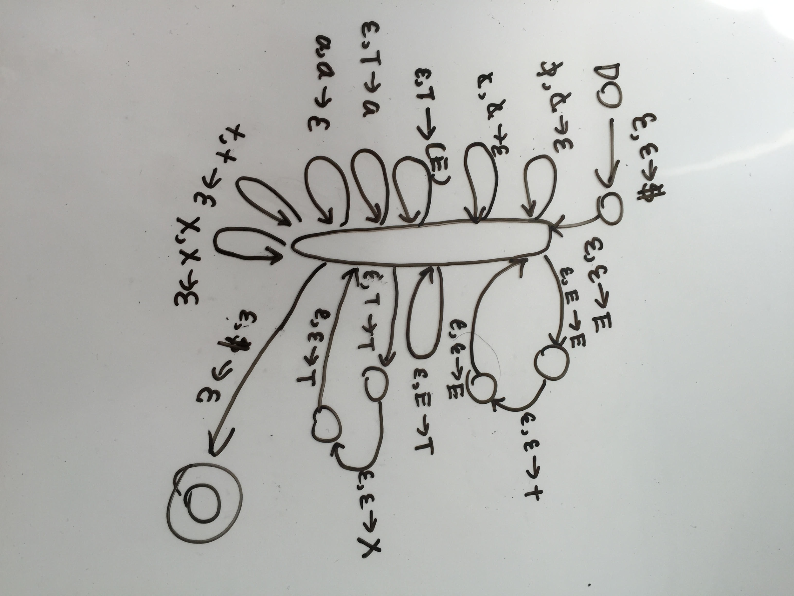

### 3.

Convert grammar G from (2) to Chomsky Normal Form.

E -> E + E

E --> T

T -> T x T

T --> (E)

T --> a

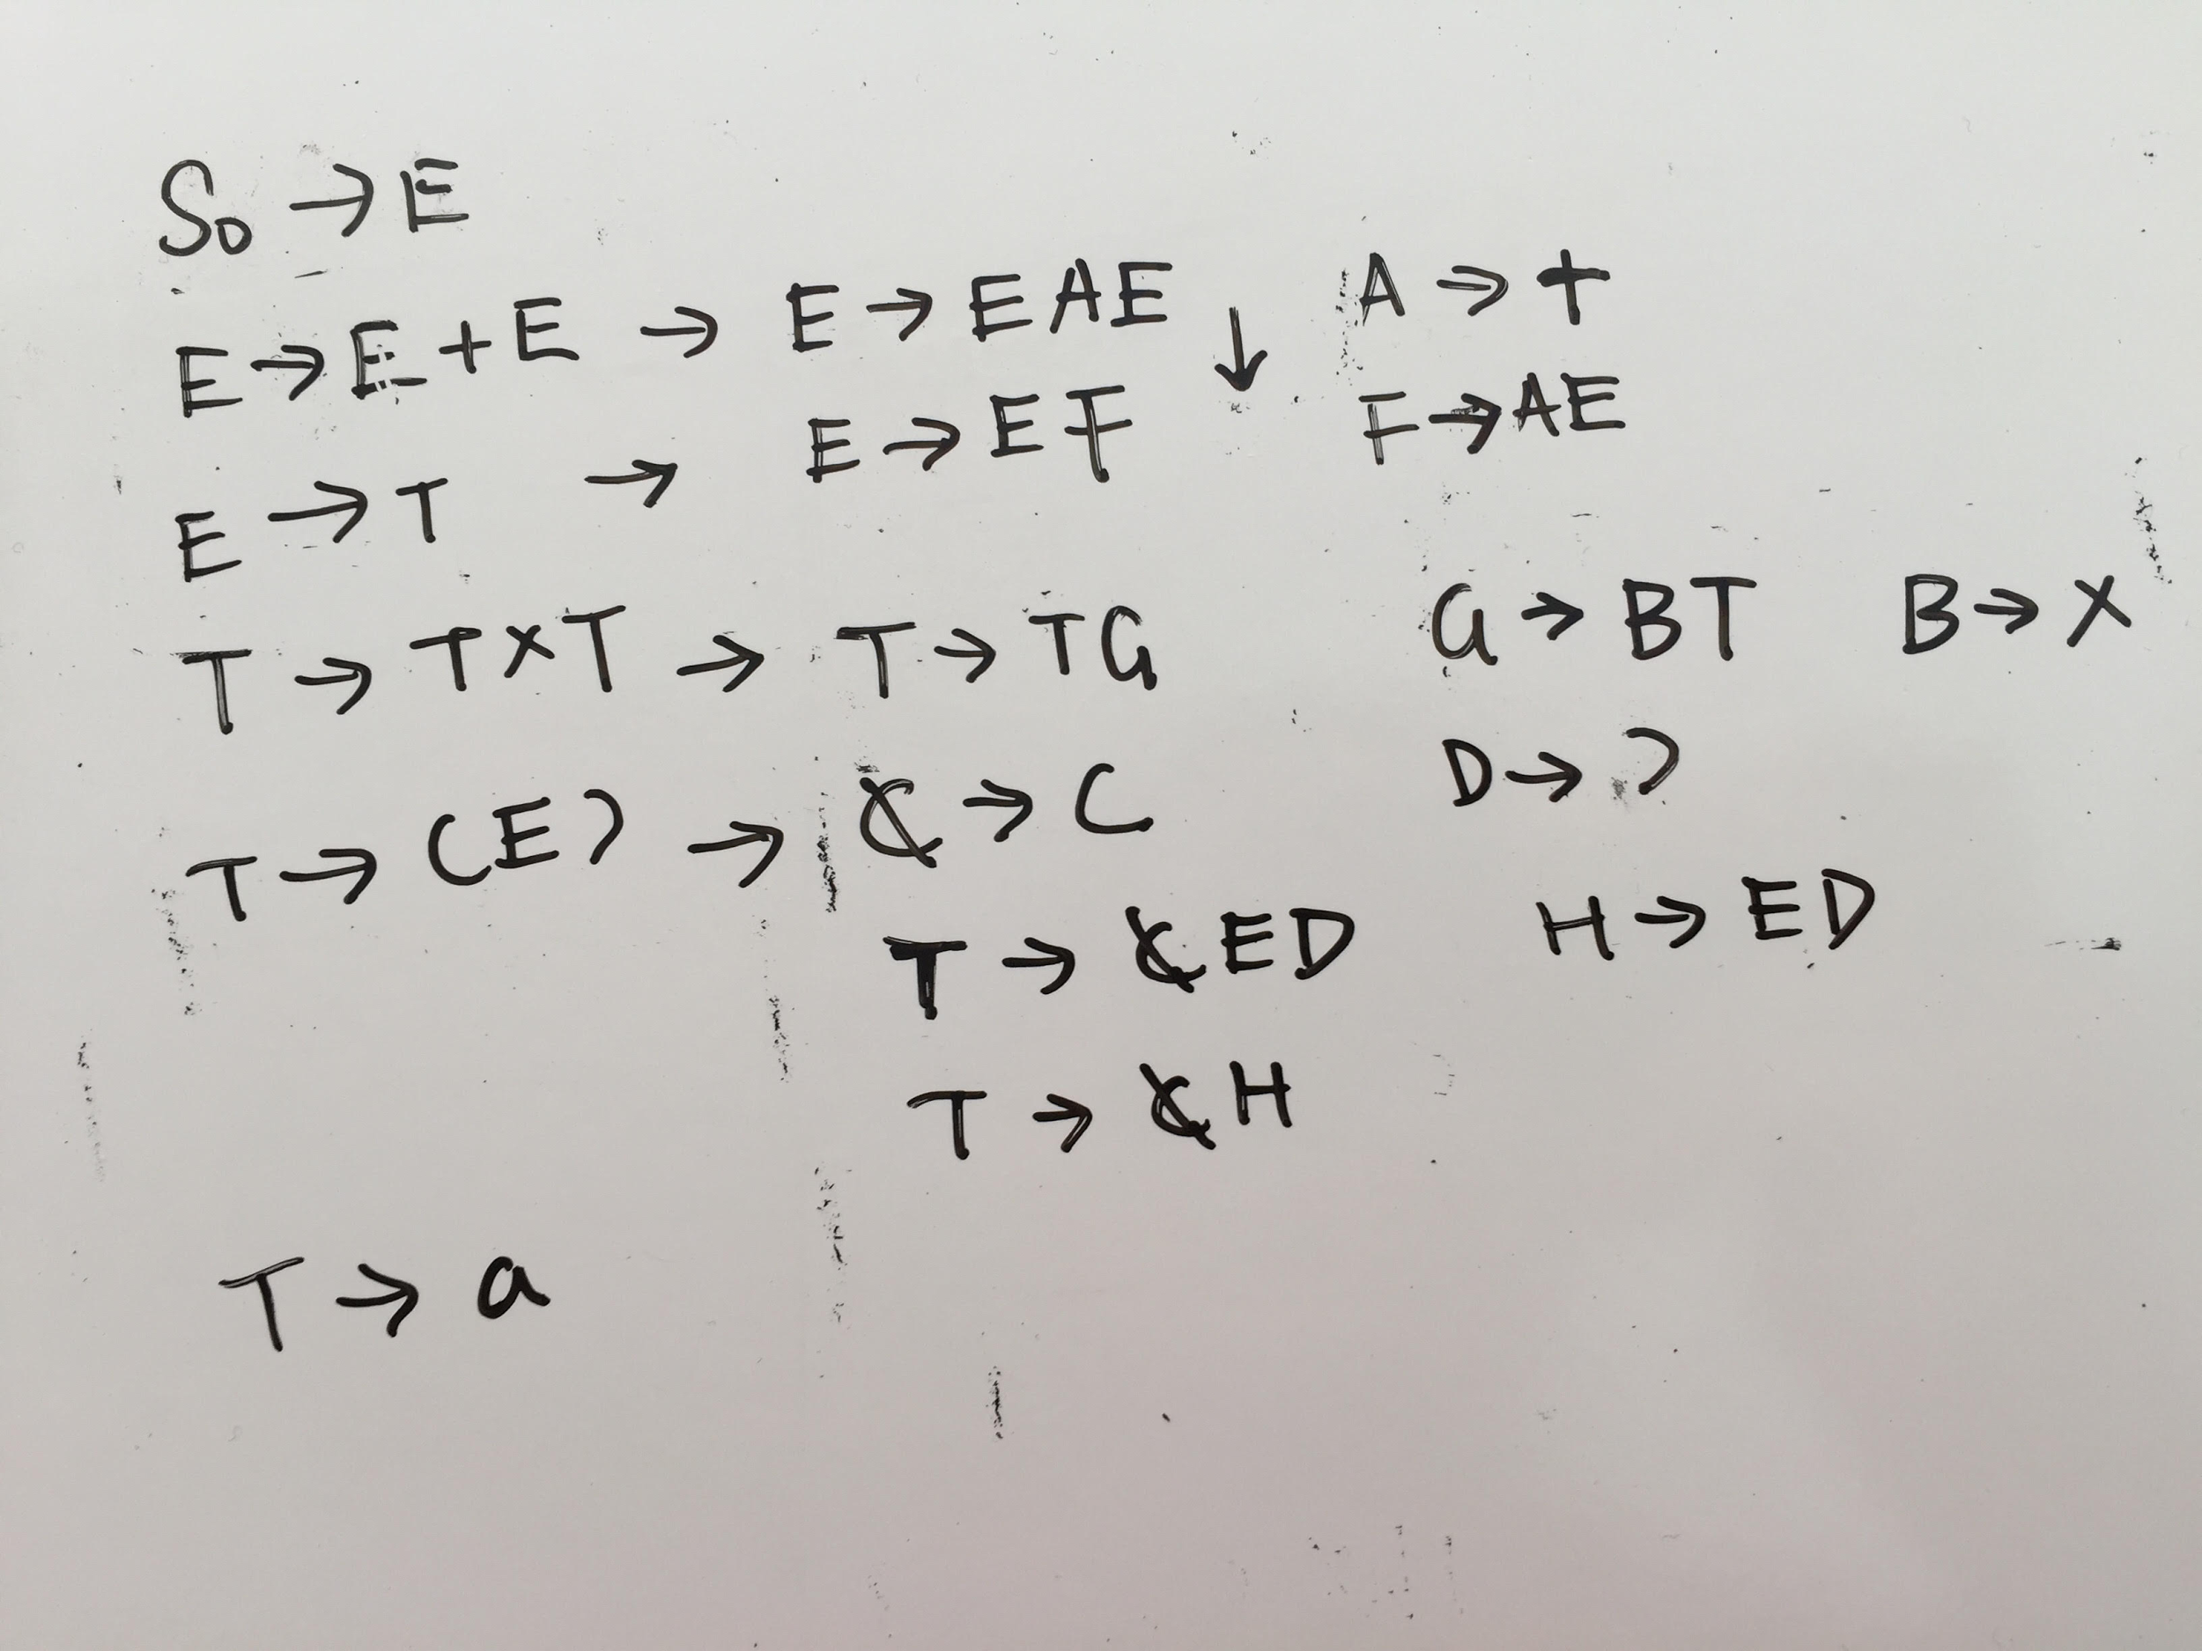

### 4.

Is the grammar G's language a regular language? If yes, produce a FSA or regular expression for this language. If not, show this.

Grammar G is not a regular language since we have rules: E --> T and T --> (E). These two rules allow us to produce unlimited number of nested parentheses. In order to figure out if the parentheses match, we need to have infinite states thus the grammar G is not regular. This is similar to the language a^n b^n which is also not regular at all from previous assignment.

### 5.

Theorem 1: The language {a^n b^n c^n} is not a context-free language.

a. Use Theorem 1, together with the languages {a^i b^i c^j} and {a^i b^j c^j}, to show that the set of context-free languages is not closed under intersection.

For a string in the intersection of both languages {a^i b^i c^j} and {a^i b^j c^j}, that means we have i = j. So the string in the intersection of these two languages is the same as the strings in the language {a^n b^n c^n}. Since theorem 1 is given that this language is not context-free language, then the intersection of these two context-free langugages is not context-free language.

b. Use the pumping lemma for context-free languages [Sipser pp. 125] to prove Theorem 1.

L = {a^n b^n c^n| n ≥1}

If L is a context free language then L must satisfy pumping lemma so L should be pumpable.

Choose a number n of the pumping lemma. Then, take z as a^n b^n c^n. We should be able to break z into uv^ixy^iz and

|vwx| ≤ n, vx ≠ ε. There are two cases for the looping here:

First, vy contains all the variables, then either v or y will have two variables, if we increase the value of i then the whole string will be out of order. Thus it will not be in the language anymore.

Second, vy contains only two of the three variables. In this case, increasing i will make the total number of a, b and c respectively unequal. Thus the new string wil not be in the language anymore.

Since we have a contradiction here, the grammar is not context free language.

### 6.

Consider the context-free grammar G:

```

S -> NP VP

NP -> NP PP

NP -> DET N

VP -> V NP

VP -> VP PP

DET -> a | the

N -> boy | girl | flowers | binoculars

V -> touches | sees

PP -> P NP

P -> in | from | with

```

a. Show that the string "the girl touches the boy with the flower" has two

different leftmost derivations.

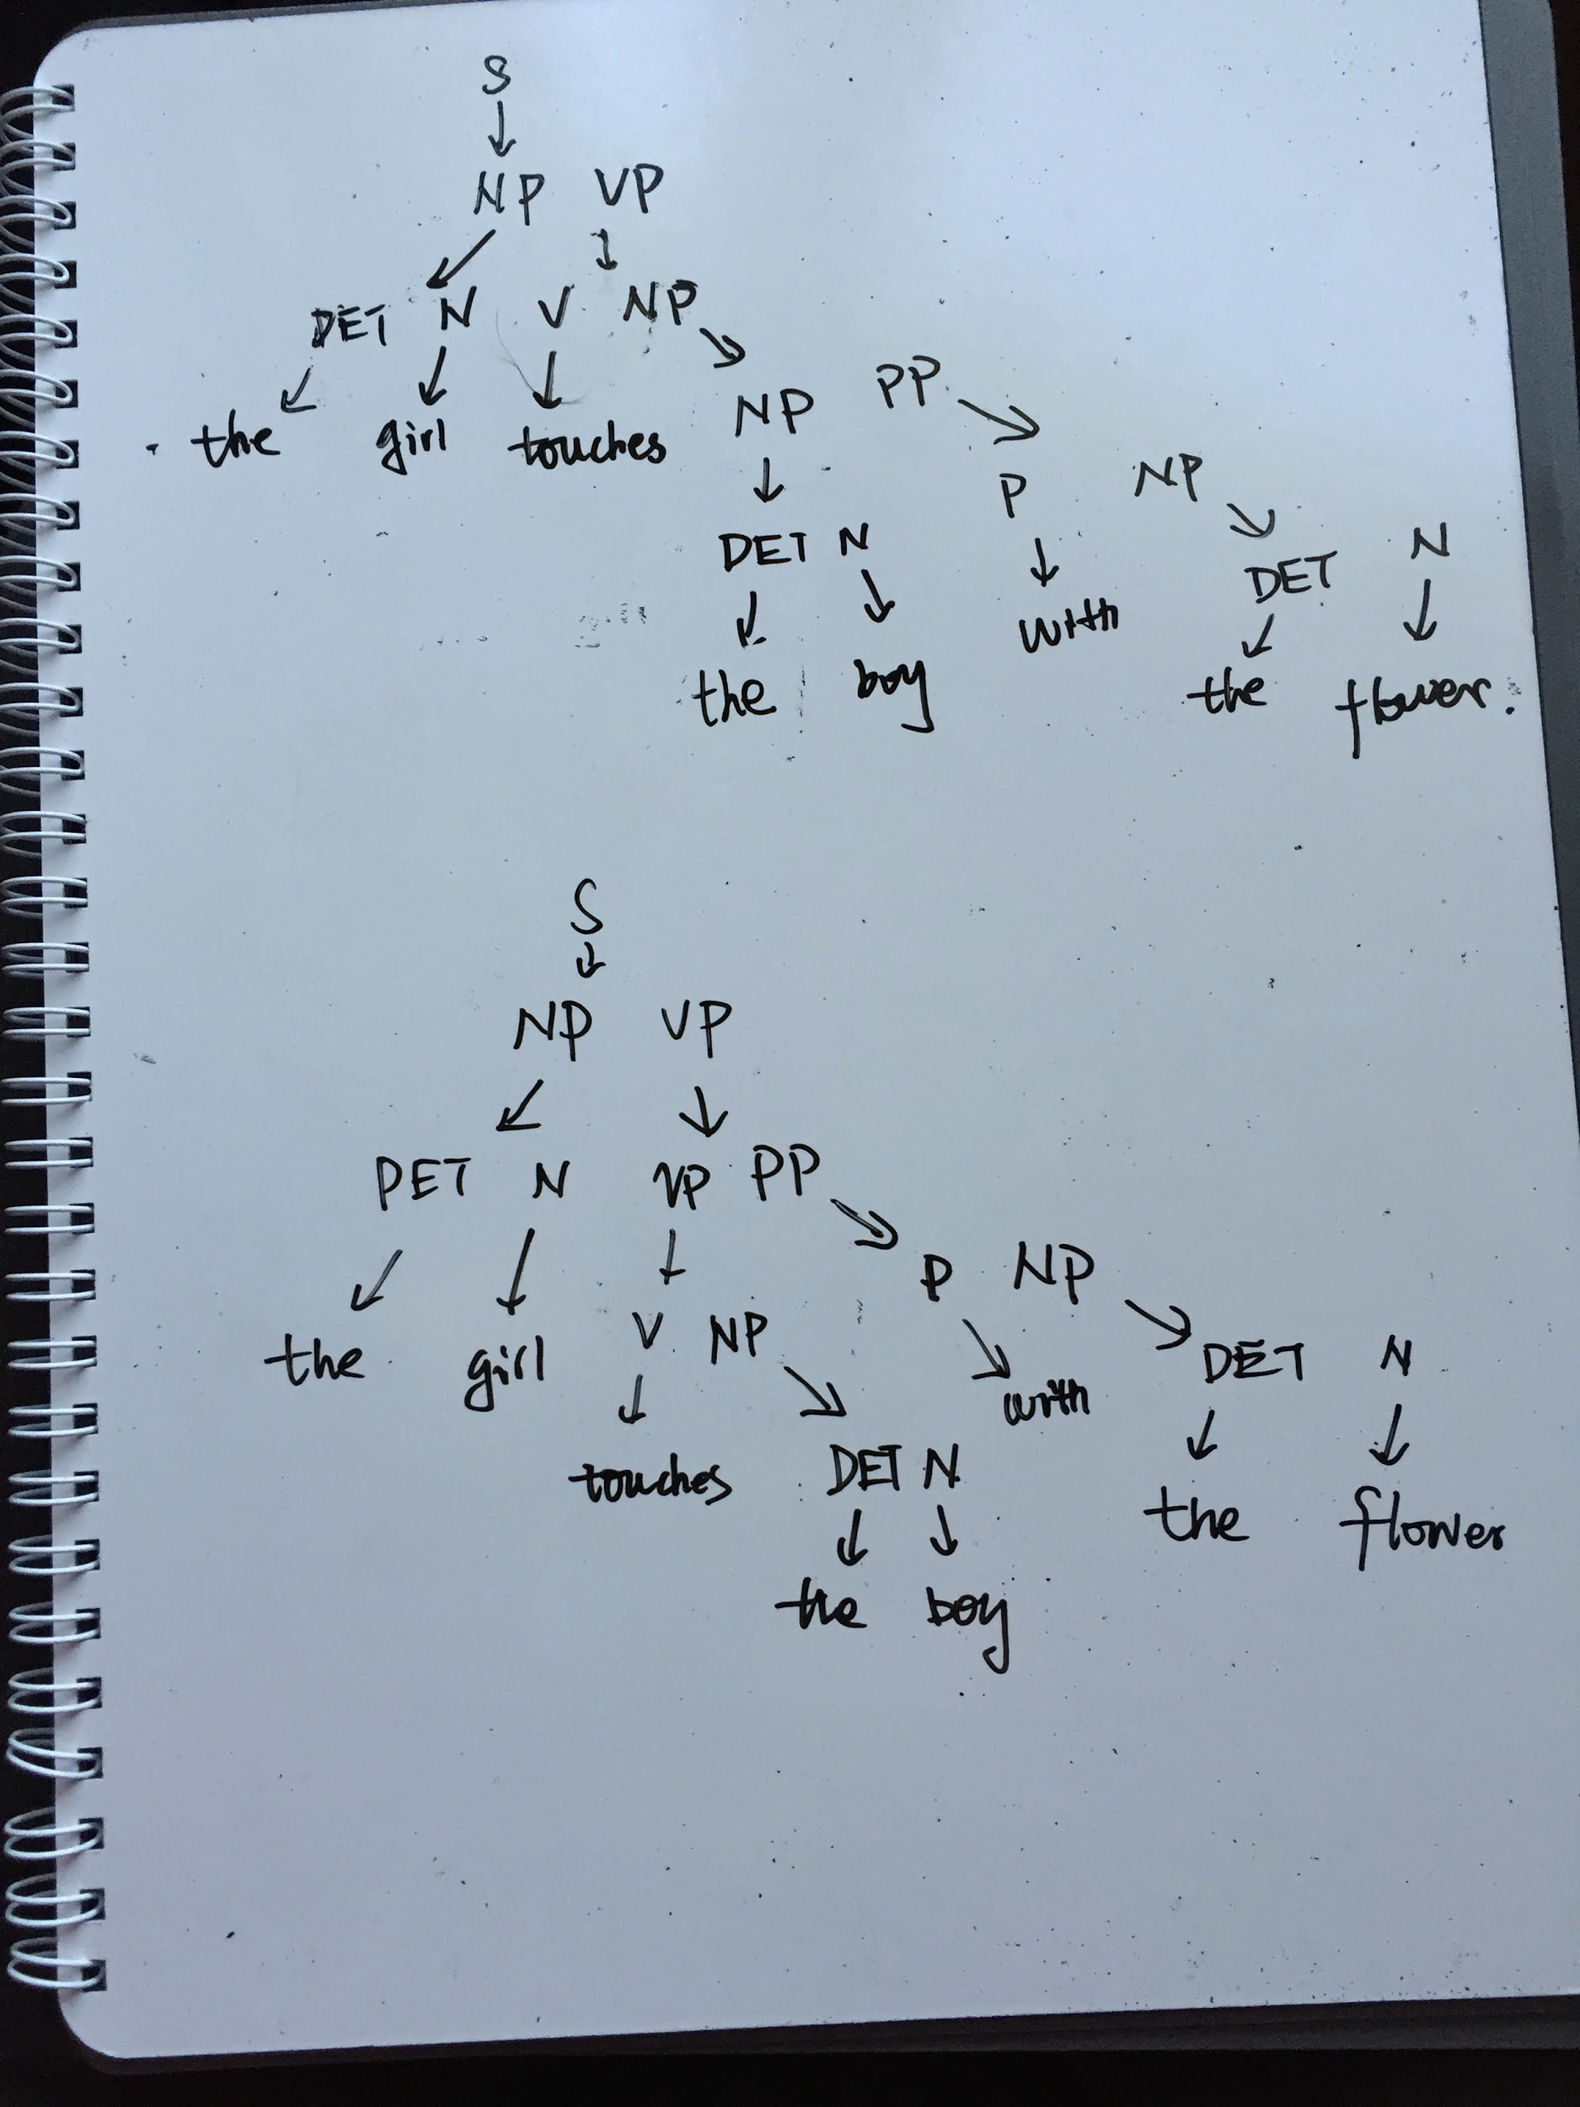

b. Describe in English the two different meanings of this sentence.

The first derivation means that the girl touches the boy who has the flower.

The second derivation means that the girl uses the flower to touch the boy.

c. Use G to generate another ambiguous sentence.

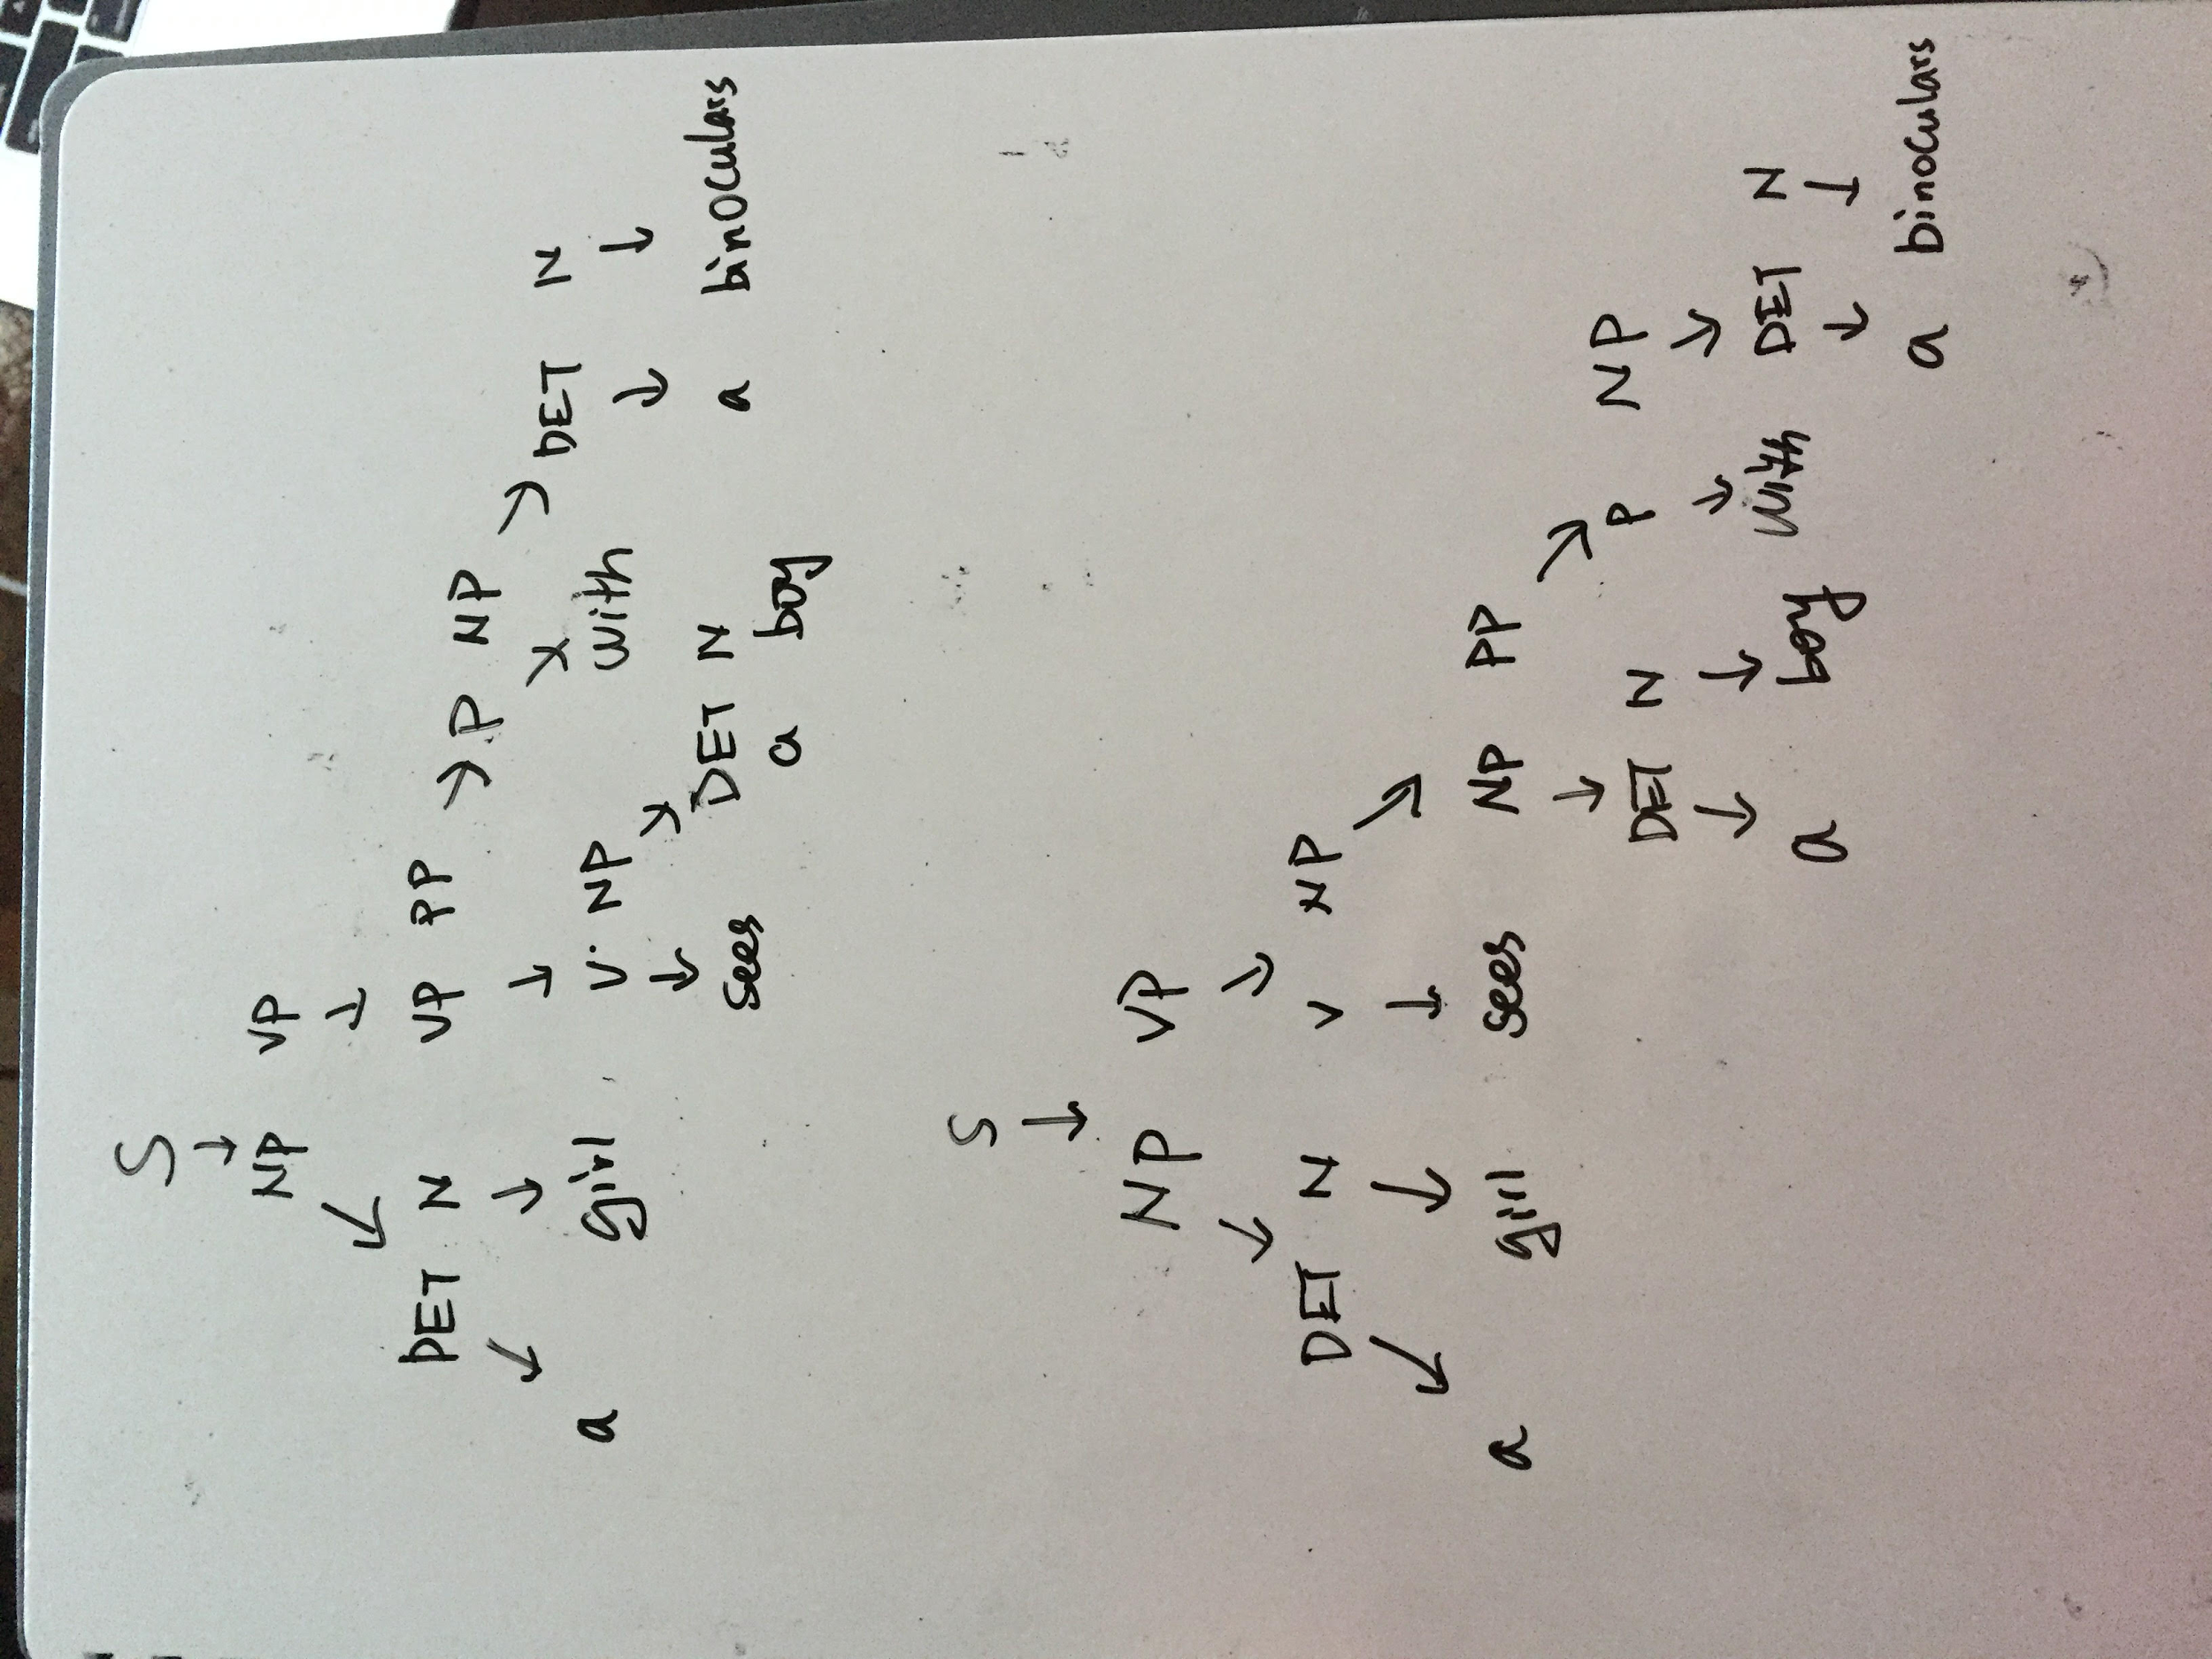

d. Modify G so that it generates strings with adjectives: `the girl saw the tall boy`, `the girl touches the boy with a purple flower`.

```

S -> NP VP

NP -> NP PP

NP -> DET N

NP -> DET ADJP

ADJP -> ADJ N

ADJ -> tall | purple

VP -> V NP

VP -> VP PP

DET -> a | the

N -> boy | girl | flowers | binoculars

V -> touches | sees | saw

PP -> P NP

P -> in | from | with

```

You don't need to know this, but here's how the variable names relate to linguistics.

Variable | meaning

---|---

S | sentence

DET | determiner (article)

N | noun

NP | noun phrase

P | preposition

PP | prepositional phrase

V | verb

VP | verb phrase

[Adapted from Sipser 2.8.]